**2D Platformer**

A classic game where you need to reach the end of the level to proceed.

* **Objectives**
  + Reach the end platform of the level to proceed to the next level.
  + Collect coins to improve your score
  + Enemies are scattered throughout the level, defeat them to receive bonus points
* **Code**
  + **Movement Script**
  + **Manager Script**
  + **Projectile Script**

**Movement Script – Move Function**

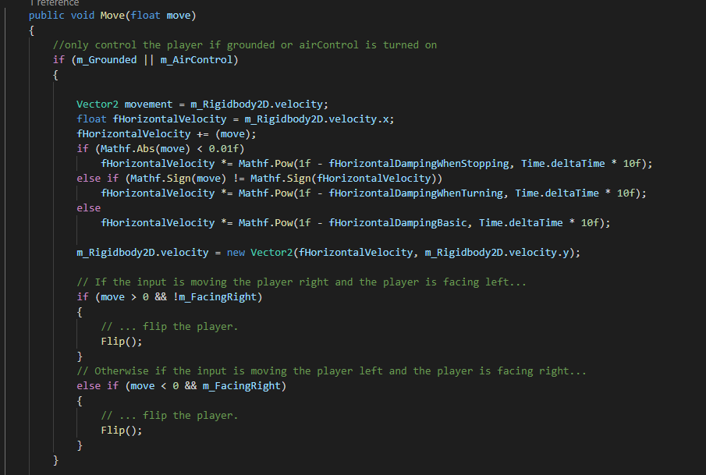

A function that allows the player to move smoothly in the level, uses the “Horizontal” Button of unity as input (-1, 1, or 0), and multiplies the value to damp the movement across the level.

It also checks if the player is on the ground and if the player is on air. Called in the Update() Method.

**Movement Script – Flip Function**

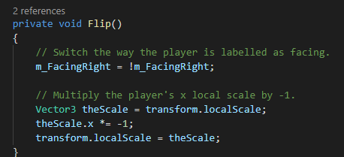

Flips the player sprite according to its input direction. Uses the Transform.LocalScale.x to flip the sprite

**Manager Script –**

A single instance that manages the level functionality, UI, and the player behaviour.

**Manager Script - PrepareLevel/Retry Level Function**

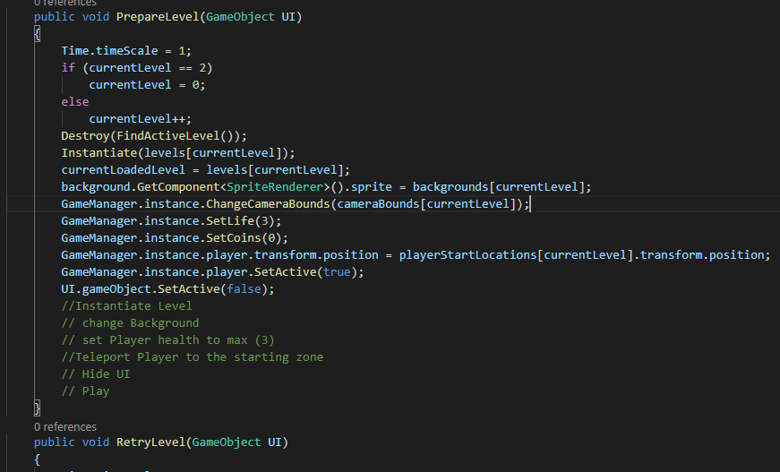

Used to reload the level without reloading the entire scene, it sets the players position to the starting position, Deletes the entire level GameObject, Instantiate a new/ current level (based on index), disables the UI, sets the life of the player, sets the coins to zero, change the camera bounds(limits camera movement)

**Manager Script – PlayerInvul function**

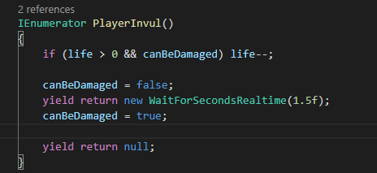

If the player is damaged. Temporarily make the player invulnerable for fixed amount of time. Then re-enable the canBeDamaged again.

**Projectile Script –**

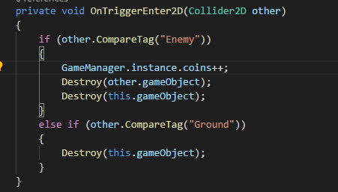

If the projectile GameObject collides with an enemy tagged with (“Enemy”/”Ground”) Destroy this GameObject and the “Enemy” GameObject

**Trigger Script –**

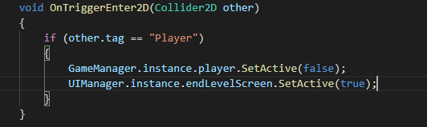

Finish the level when the player collides with this GameObject. Show the End Level UI and disable the player so that it cannot move.